Electronics Documentation

1. Electronics Block Diagram
INITIAL BLOCK DIAGRAM:
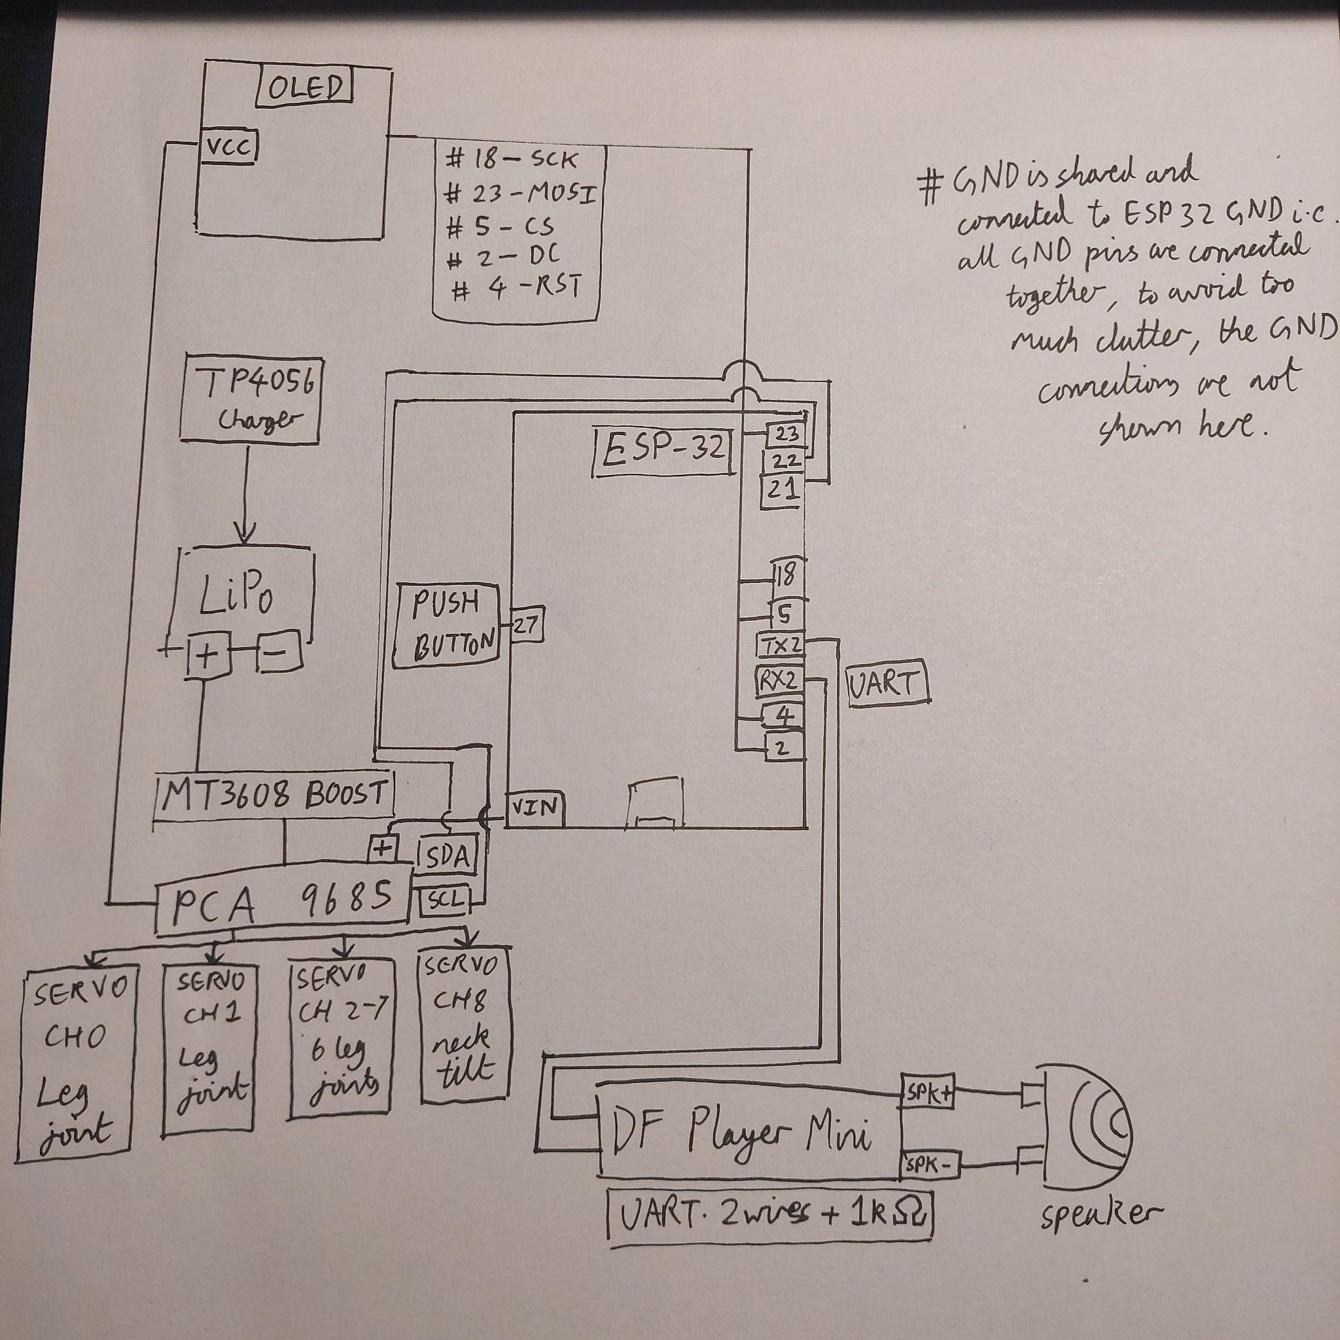

FINAL CIRCUIT/BLOCK DIAGRAM: (without updated switch connections)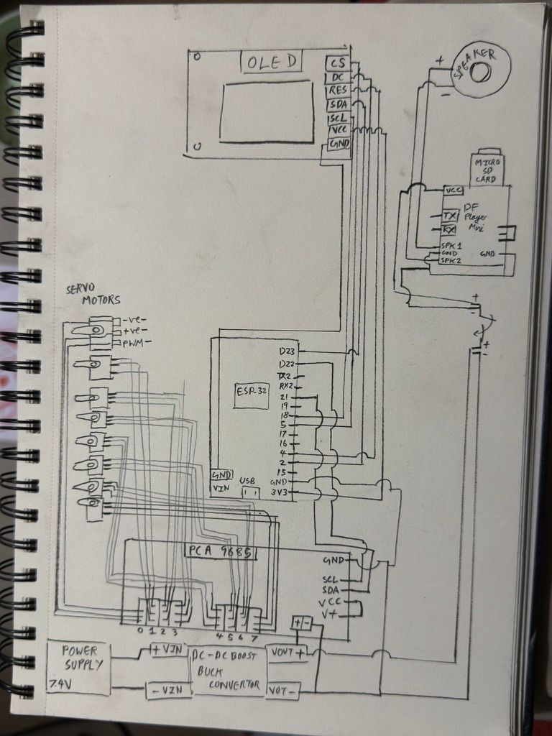

2. Components Table
Component | Quantity | Purpose | Justification
MG90 Servo  motors | 8 | To move the individual hip and knee for all four legs in the quadropod | Servos provide robust and smooth motion and are small enough and multiple can be controlled at a time
PCA9685 | 1 | Provides PWM signals to control the position of multiple servo motors using i2c | We need a driver for all the servos and this is the most reliable one
DC-DC BOOST  BUCK CONVERTOR | 1 | Converts incoming 7.4v to 5v | We need constant 5v power supply to the electronics in this circuit. We checked this using a multimeter
DF PLAYER MINI | 1 | Used to playback mp3 music from an sd card | Low cost mp3 module designed for audio playback and doesnt need to be connected to a microcontroller to just normally play audio tracks,avoids complexity
Speaker | 1 | Speaker is used to output the audio from the df player | We chose a 8 ohm, 0.5W cause of its small form factor and ease
ssd1309 oled display | 1 | Takes bit map images sent to it and converts it into sequences displayed on the screen | We chose this 2.4 inch display due to it’s high quality oled and larger pixel grid size
Justification is important

DETAILED OVERVIEW OF SERVO MOTORS AND CALIBRATION ‘
Each servo was connected to the channels of the pca9685 i.e. channels 1 to 7.
After this, each servo was placed into the 3d printed units, which would later prove to be a mistake as we had not calibrated it properly yet.
I originally tried to use the concept of oscillator, i.e. the sin wave concept inspired by how keyframe animations in the free software bottango.
We tried doing that in bottango:
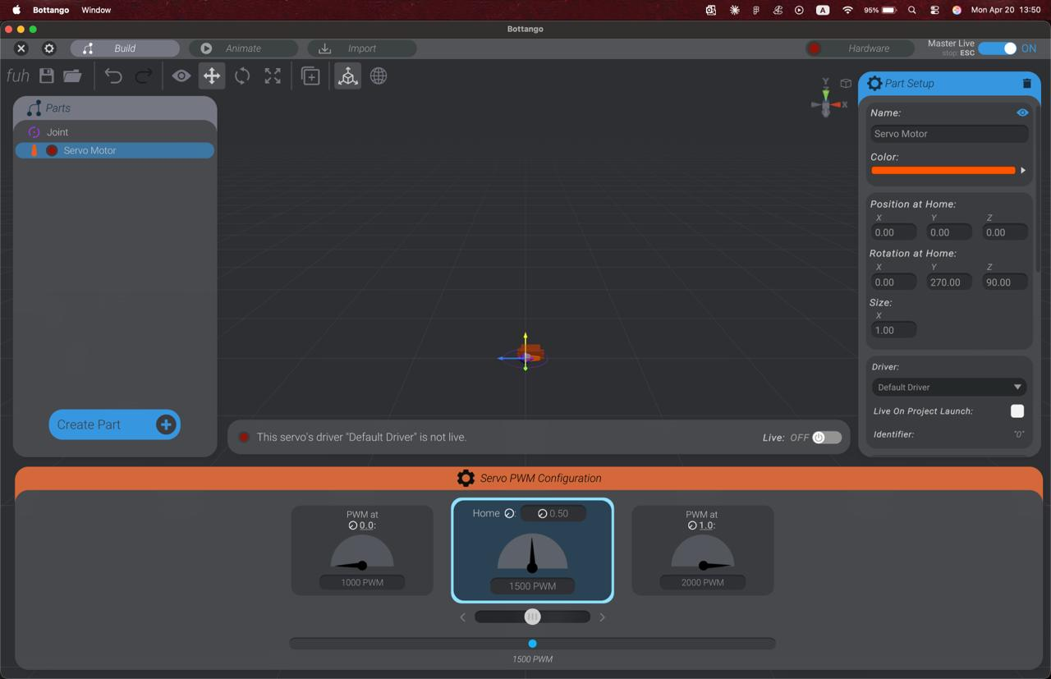
However, it failed as we were unable to convert the code into the numbers required for the servo animation and we struggled to understand what to extract from the C++ code.
We then decided we have to manually calibrate each servo

FOR THE CALIBRATION:
We ran an i2c based library for the pca9685. We then used it to run the respective servo movements for each channel and tested the direction of rotation and the angle swept, after heaps of trial and error not only with the direction of movement but making sure the shaft does not lock out of the housing of the hip and knee indentations cause calibration gets faulty once that happened.
We finally decided on the final calibration for each servo:
# Ch 0 = Front-Right TOP (hip) home=0 moves 0→90 (0=standing)
# Ch 1 = Front-Left TOP (hip) home=90 moves 90→0 (90=standing)
# Ch 2 = Back-Left TOP (hip) home=0 moves 0→90 (0=standing)
# Ch 3 = Back-Right TOP (hip) home=90 moves 90→0 (90=standing)
# Ch 4 = Front-Right BOTTOM (knee) home=0 moves 0→150 (0=standing)
# Ch 5 = Front-Left BOTTOM (knee) home=150 moves 150→0 (150=standing)
# Ch 6 = Back-Left BOTTOM (knee) home=0 moves 0→150 (0=standing)
# Ch 7 = Back-Right BOTTOM (knee) home=130 moves 130→0 (130=standing)

DEBUGGING/PITFALLS FACED:
- WOKWI SIMULATIONS FAILED TO WORK
- BOTTANGO SIMS FAILURE
- SERVO CALIBRATION ISSUES
- OSSCILATOR ANIMATION SEQUENCE VERY UNRELIABLE , HARD CODED ANGLE MOVEMENTS PREFERRED INSTEAD

